**THEORY OF AUTOMATA**

CSC-315

**ASSIGNMENT NO. 4**



**Department of Computer Sciences**

**BAHRIA UNIVERSITY, ISLAMABAD**

**ASSIGNMENT NO. 4**

**QUESTION:**

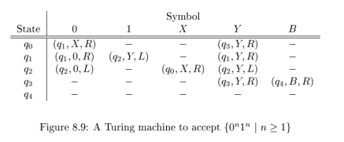

**Show the ID’s of the turning machine of fig.8.9 if the input tape contains**

**PART A:**

**00**

**ANSWER:**

|  |
| --- |
| q000 -> Xq10 -> X0q1B without accepting |

**PART B:**

**000111**

**ANSWER:**

|  |
| --- |
| q0 000111 |- Xq1 00111 |- X0 q1 0111 |- X00 q1 111 |- X0 q20Y11 |- X q2 00Y11 |- q2X00Y11 |-X q0 00Y11  |-XXq1 0Y11 |- XX0 q1 Y11 |-XX0Yq1 11 |-XX0q2 YY1 |-XXq2 0YY1 |-Xq2 X0YY1 |-XX q0 0YY1 |-XXXq1 YY1  |-XXXYq1 Y1 |-XXXYY q1 1|-XXXY q2 YY |-XXX q2 YYY |-XX q2 XYYY |-XXX q0 YYY |-XXXY q3 YY |-XXXYY q3 Y  |-XXXYYY q3 B |-XXXYYY Bq4 B and the machine halts in accepting state. |

**END OF ASSIGNMENT**